Data Flow Diagram

Date | 26 June 2026
Team ID
Project Name | A Comprehensive Measure of Well-Being
Maximum Marks | 2 Marks

Data Flow Diagram
The Data Flow Diagram (DFD) illustrates how data flows through the Human Development Index Prediction System. It shows the interaction between the user, the Flask web application, the machine learning model, and the prediction result. The DFD represents how user inputs are processed to generate the predicted Human Development Index (HDI) category.


DFD Symbol Legend

Symbol | Name | Description
Oval / Rounded shape | External Entity | A person, organization, or system outside the project that sends or receives data (e.g., Customer, Payment Gateway).
Rectangle with numbered header | Process | An activity that transforms incoming data into outgoing data (e.g., Validate Request, Process Order).
Rectangle (solid fill, no number) | Data Store | A place where data is held for later use (e.g., Customer Database, Inventory).
Labeled arrow | Data Flow | The movement of data between entities, processes, and data stores, labeled with what data is being passed.

Data Flow Diagram:



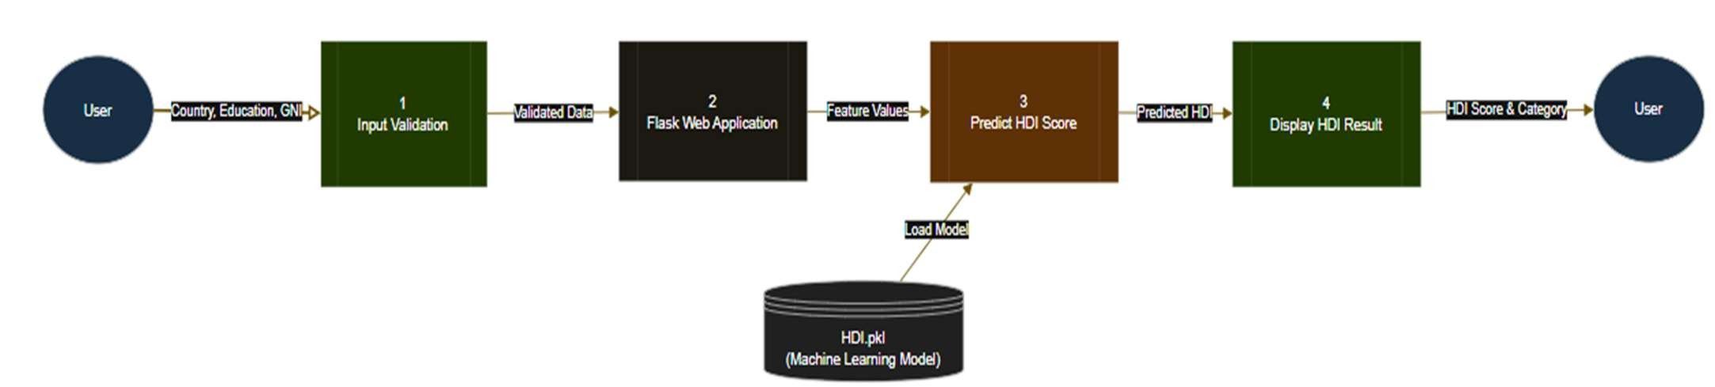

ER Diagram:

